Welcome to the NRDE System!
There are 3 ways to bind a new policy.

Please note: Your screen may look slightly different

1. You can click on the “New Application” link; or
2. Click on the product you want to and a list of plans will appear. Then, you can click “Purchase”.

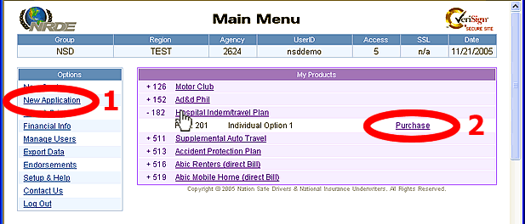

Both options will take you to the “New Application” page where you can select coverage(s). Then, type the insured’s name, address, and any other information that may be required. When you are done, click the “Save and Print” button at the top.
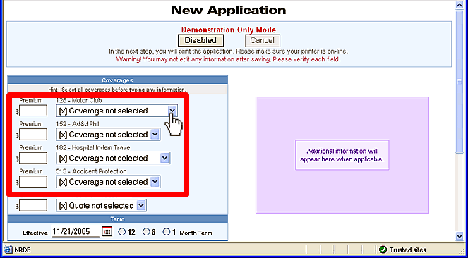

3. The last method is only for products that do not have a pre-set premium. Currently, only products Renters Insurance (products 515 & 516), Mobile Home Insurance (products 518 & 519), and Supplemental Auto Travel (product 511). These products require a quote before you can proceed to the “New Application” page.

On the “Main Menu”… click on the “New Quote” link.
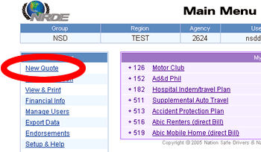

Then, select a product from the dropdown menu, fill in all required information and options, and click “Get Quote” (label A).

After you receive the quote you want, click either:
- “Save Quote” (label B) to save the quote and quote another product; or
- “Proceed to Bind >>” (Label C) to save quote and go to the “New Application” page to Bind.
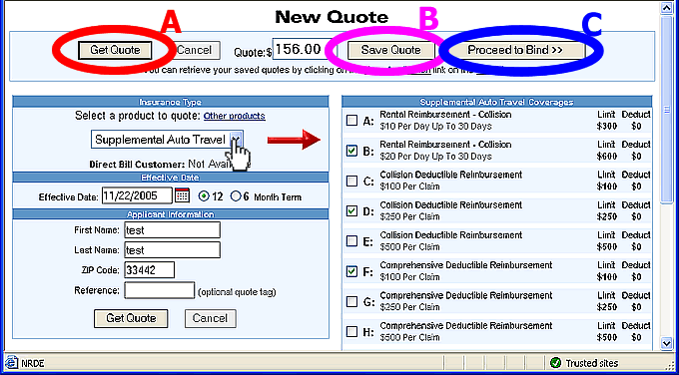

After you quote a product, you must bind the quote on the “New Application” page.

Just select your quote from the “Quoted Insurance Products” section (always the last dropdown), then, provide the remaining information.
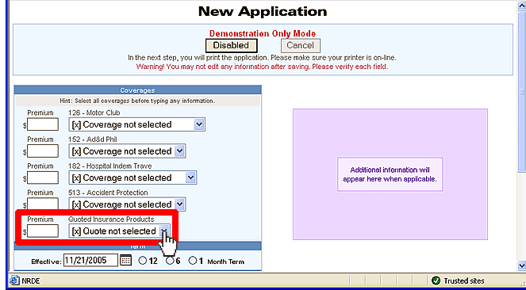
Please note: you can select multiple coverages simultaneously.

